In Class Activity
Montfort et al, Chapter 50

1. Read the first sentence of page 148, and explain its connection to Douglas Rushkoff’s argument from III. Choice, which reads: “In the digital realm, everything is made into choice. The medium is biased toward the discrete. This often leaves out things we have not chosen to notice or record, and forces choices when none need to be made” (52).

2. 10 PRINT constitutes the programming language BASIC. Look up BASIC in Wikipedia to see what the letters stand for (if you missed it in Montfort et al’s book, chapter 50). Explain why the choice of BASIC for the Commodore is important for what Paul Ceruzzi talks about in his book (pages 113-114) relating to its contribution to the rise of personal computers and the “home brew” movement.

3. Look at the image of “time-sharing,” below (from http://motherboard.vice.com/read/the-sexy-ibm-selectric-was-the-ipad-of-1961--2). How did BASIC contribute to this “revolutionary configuration” (158)?

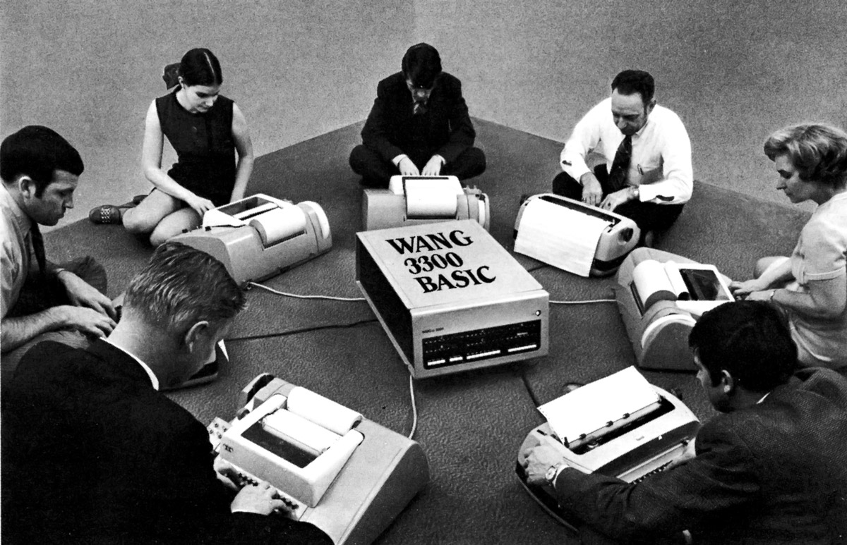

4. Who is Ada Lovelace and why is it ironic that she is considered the first computer programmer? (Hint: Think back to Ceruzzi’s book and read on in Montfort et al’s section about Ada).

5. Go to Google Images and type in IBM Punch Card. Explain how these are a remediation of a previous use of punch cards. (Hint: See Montfort et al’s page 162, or think back to what you learned from Ceruzzi’s book).

6. The idea that BASIC made it possible receive “error messages that were clear and friendly” (164) connects to expectations we have for computing devices today. Explain.

7. The authors ask us, “Why would a keyboard have a dollar sign but not a multiplication sign?” Answer that question.

8. John Kemeny, one of the two founders of BASIC, had a particular philosophy that seems to underpin his approach to programming languages. Explain. Then connect this approach to Rushkoff’s notion of X. Purpose.

9. What is POKE and PEEK, who invented them, and why?

10. Explain the logic of making a computer system that addresses both sides of a two-sided market? Cite an example.

11. Describe the fracas that generated from the Copyleft, hobbyists, and Hacker culture and the locked down model of proprietary software associated with computer corporations.

12. Watch this ad highlighted in Mortfort et al’s book: http://www.youtube.com/watch?v=JyxSihHpPhw. Explain the point the ad was trying to make about the machine.

13. The section beginning with “The Circulation of BASIC programs” (page 182-190) provides evidence of BASIC’s cultural influence. Sum this up for me.

14. What are the three main contributions of BASIC to personal computing? (Hint: See section, “Late BASIC”).

15. What is the legacy of BASIC today?

