**Resources for Curating Electronic Literature**

**1. Exhibit Archives.** Includes information such as curatorial plans, curatorial statements, impact reports, and images; provides a model for how to document and archive a live exhibit for a long-term scholarly study of electronic literature, curatorial practices, aesthetics, and digital culture.

[Moving Words: An Exploration of Kinetic Poetry and Prose, 1984-2014](http://dtc-wsuv.org/elit/moving-words/). Illuminations Gallery, National University of Ireland Maynooth. March 2014.

[“Pathfinders: 25 Years of Literary Experimental Art.”](http://dtc-wsuv.org/wp/pathfinders/exhibit/)The Modern Language Association 2014 Convention.  With Stuart Moulthrop.  January 2014.

“[Exploring the Electronic Literary Landscape of the Pacific Northwwest](http://dtc-wsuv.org/elit/elit-dhsi).”  With Brenda Grell.   The  2013 Digital Humanities Summer Institute.  Victoria, Canada.

“[Electronic Literature & Its Emerging Forms](http://dtc-wsuv.org/elit/elit-loc).”  With Kathi Inman Berens.  Library of Congress, Washington D.C. April 3-5, 2013.

[“Avenues of Access: An Exhibit & Online Archive of ‘Born Digital’ Literature.](http://dtc-wsuv.org/elit/mla2013/) The Modern Language Association 2013 Conference. With Kathi Inman Berens. Boston, MA. January 2013.

[“Electrifying Literature.”](http://dtc-wsuv.org/elit/elo2012/elo2012/Welcome.html) With Sandy Baldwin. The ELO 2012 Conference. Morgantown, VW. June 2012.

[“Electronic Literature.”](http://dtc-wsuv.org/mla2012/) The Modern Language Association 2012 Conference. With Lori Emerson & Kathi Inman Berens. Seattle, WA. January 2012.

[“mediartZ: Art as Experiential, Art as Participatory, Art as Electronic.”](http://www.nouspace.net/mediartZ/mediartZ/Welcome.html) North Bank Artists Gallery. Spring 2009.

[“Visionary Landscapes.” The Electronic Literature Organization Media Art Show.](http://dtc-wsuv.org/elit/elo08/) North Bank Artists‘ Gallery & Clark College. June 2008.

**2. Curatorial Plans.** Provides an understanding how to layout an exhibit, focusing on the relationship involving the works, audience, space, and curator’s vision.

Kallisto:Users:dene:Dropbox:Moving Words:Information:moving-words-floor plan.pdf

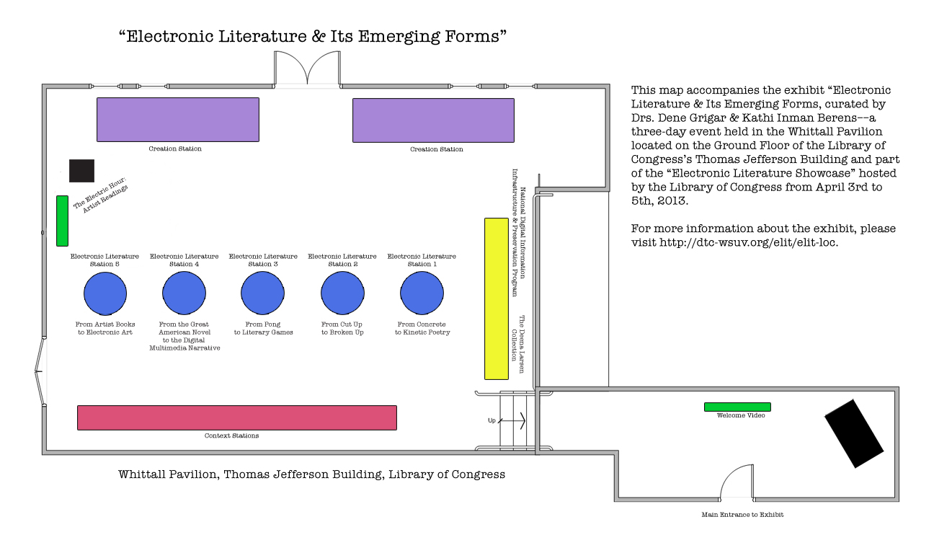

**3. Impact Reports.** Provides a model for documenting the success of an exhibit with an eye toward pursuing future funding (e.g. grant, budget) for a venue, exhibit, or scholarship.

Electronic Literature & Its Emerging Forms. Library of Congress. <http://dtc-wsuv.org/elit/impact-report.pdf>

Electronic Literature. Modern Language Association 2012 Convention. (Published at *Authoring Software*, with introduction) <http://www.narrabase.net/mla2012_report.html>.

Avenues of Access. Modern Language Association 2013 Convention. (Posted at HASTAC). <http://www.hastac.org/blogs/dgrigar/2013/03/01/mla-2013-electronic-literature-exhibit-impact-report-0>.

**4. Course Materials**. Provides syllabi, suggested readings, class activities, and slide shows keyed to textbook.

Curating Multimedia Exhibits. <http://dtc-wsuv.org/wp/curating/>.

**5. Potential Materials Needed**. Provides suggestions for items to include when developing the budget associated with a curatorial plan.

Vinyl for authors’ names/works for walls

Signage for specific information about the authors and works

Frames for artist statements

Computers/tablets/smart phones/touch screens/smart TVs

Projectors/projection system/projection screen

Secured mounts for smart devices/cables for securing computers

Sound system/headphones

Tables & chairs/pedestals

Toolbox with gallery tape, blue tack, hammer/nails, computer cleaning supplies, level, ruler

**6. Promotional Materials**. Includes suggestions for both print and non-print materials.

Press releases

Announcement cards

Gig posters

Facebook page, with event page included

Twitter hashtag

Background image for computing devices