Dick Hannah Style Guide
Contents
Global specs 2
Color schemes 2
Fonts 3
Sizes and colors 3
Main navigation 3
Dropdown menus 3
Sub-navigation 3
Content boxes 5
Information boxes 5
Attention boxes 5

Global specs
All DH sites are 1000px wide; this was determined by their main user based screen resolution size of 1280x800px and 1024x768px.

Color schemes
These are 4 color schemes used. The differences between the five are in the main navigation and all call-to-action buttons. The following schemes and sites per scheme are:
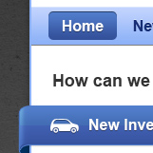 | Light blue/blue used for:  - Main DH  - Honda  - Hyundai  - Subaru  - VW (Portland)  - VW (Vancouver)
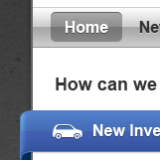 | Chrome/Blue used for:  - Acura  - Chrysler  - Ram  - Scion (current site is different)
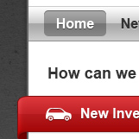 | Chrome/red used for:  - Kia  - Toyota  - Nissan  - Dodge
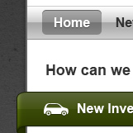 | Chrome/green used for:  - Jeep

Fonts
The font family used for all DH sites is:
- Arial, Helvetica, sans-serif

Sizes and colors
The following are font sizes, colors, and headers are used throughout all DH sites:
- Body (default) = normal 14px
  - Color: #333333
- H1 = bold 30px
  - Color: #333333
- H2 = bold 24px
  - Color: #333333
- H3 = bold 18px
  - Color: #333333

Main navigation

Dropdown menus
All main navigation menus are styled according to the scheme. Access to content inside these menus should complement the section title that’s being used:
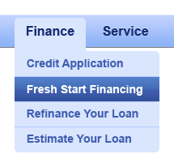

Sub-navigation
All sub-navigations should mirror main navigation dropdowns. This is done so that users can jump around to other contexts within that main navigation item. All content pages will use a two column layout with the sub-navigation towards the top of the left column, see example below:
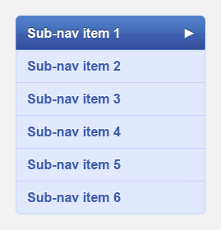
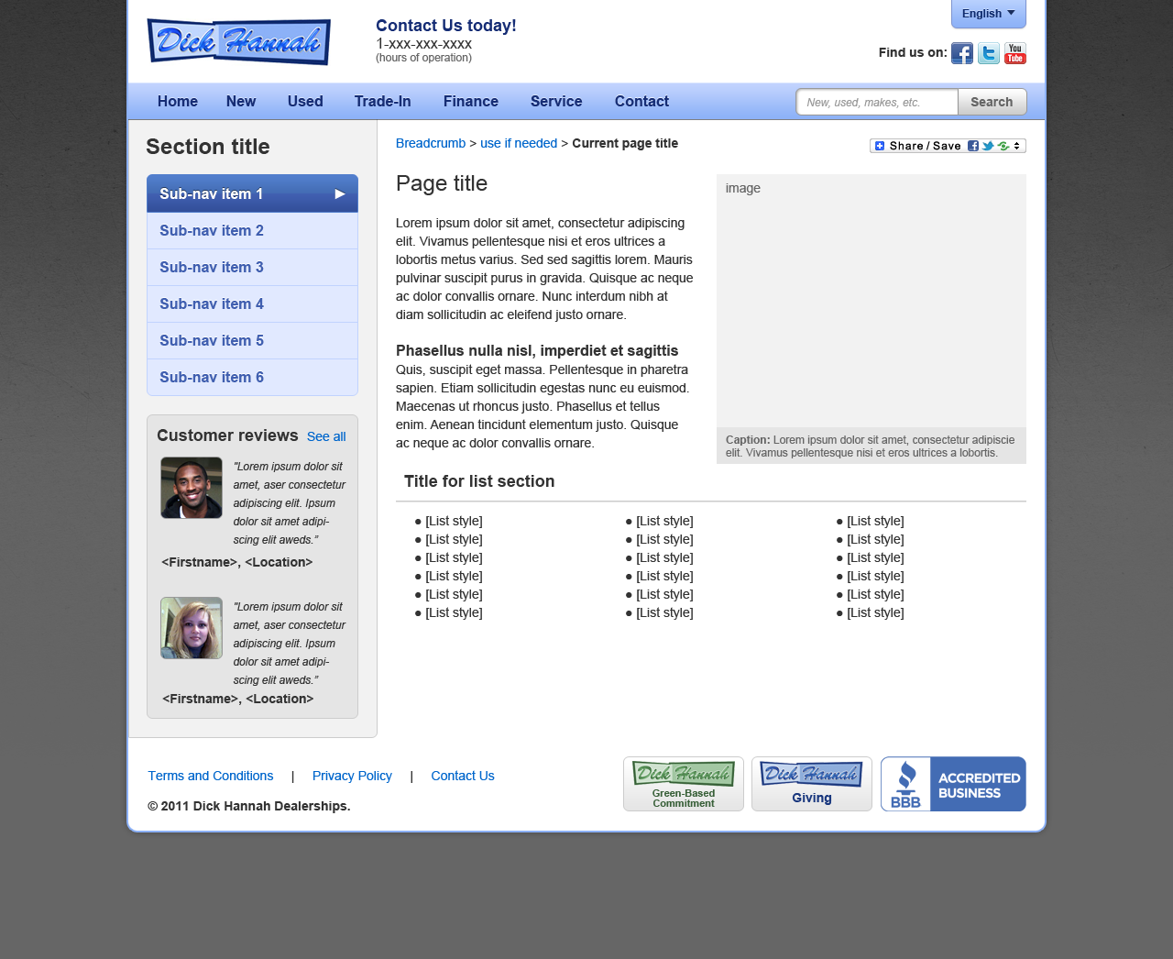

Content boxes

Information boxes
There are three types of information boxes. These are used for sequences found on the homepage. They’re specifically used to display more than one grouping of information:
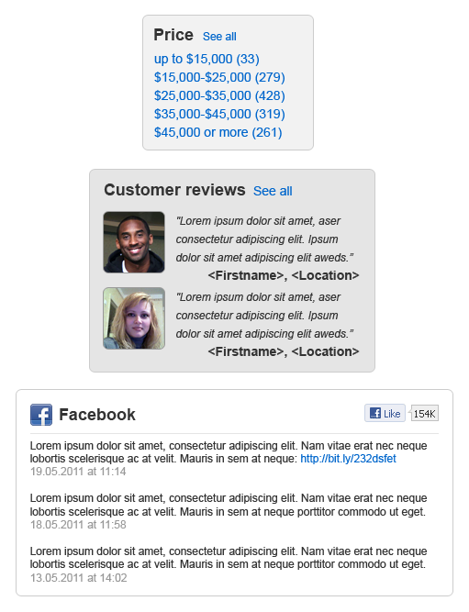

Attention boxes
These boxes are used to draw attention to elements on the page. The backgrounds to these boxes have a light blue (#e1e9ff) with a lightly darker light blue (#c1d3fe) border. A few examples are:
