**Social Media Practices:**

**Comparing Professional and Social Users’ Message Goals**

Tracy Lyon

Leandra Corvus

DTC 336 – Social Media Practices

November 21, 2019

**INTRODUCTION:**

As part of a class project during the Fall semester, 2019, our entire class collected data about various users chosen by class members in select Twitter genres from August to October of 2019. The categories of Twitter users were celebrities, athletes with less than a million followers, musicians with less than a million followers, social media marketers, politicians not running for President, a large company with more than a thousand employees, small companies with less than 300 employees, journalists, and professors or other academic people who were actually teaching at a university. Class members looked at the twenty most recent posts of each user selected, and collected data about the users, their tweets, message goals, type of media used for each tweet, the date the tweet was sent, and whether or not they used emojis in the tweet. My partner, Leandra Corvus and myself, Tracy Lyon decided to look at two specific aspects of the Twitter data that was collected by the class and compiled into one large Excel spreadsheet by the instructor, Michael Rabby. We categorized each type of user into one of two genres, business professional and social, and looked specifically at the message goals defined by each student pair who gathered the data and submitted it in class.

**QUESTION:**

If we further categorize the Twitter data into business professional and social genres what would the three predominant message goals say about these genres and how they communicate. What would this say about the top occupations within the genres connected to those message goals?

**HYPOTHESIS:**

The business professionals – in this instance small companies, large companies, social media marketers, professors, and politicians – would more likely be focused on customer service, real time communication such as direct responses, and the promotion of their brand than the social genres using Twitter, such as athletes, celebrities, musicians, and journalists. Dave Kerpen, Michelle Greenbaum, and Rob Berk wrote in the book *Likeable Social Media*, “Companies can no longer afford to ignore their customers’ specific needs or complaints when the conversation can so easily be made public. Instead they must listen, understand the issue, and respond appropriately.” (Kerpen, 2019, p 32)

**METHODS:**

Our first look at the data was to compare overall Tweeter occupations to their message goal percentage. For each occupation, we examined the message goals used in each tweet and charted it in a bar graph to identify correlations between message goals and occupation types. We then compared the same information for the two groups to see what kind of trends we would find in the smaller groups. This first look at the data showed a trend across the board that the least used message goal was charity/non-profit, while the most commonly used was promotion. We left out the “other” category because we viewed it as the potential for one-off goals.

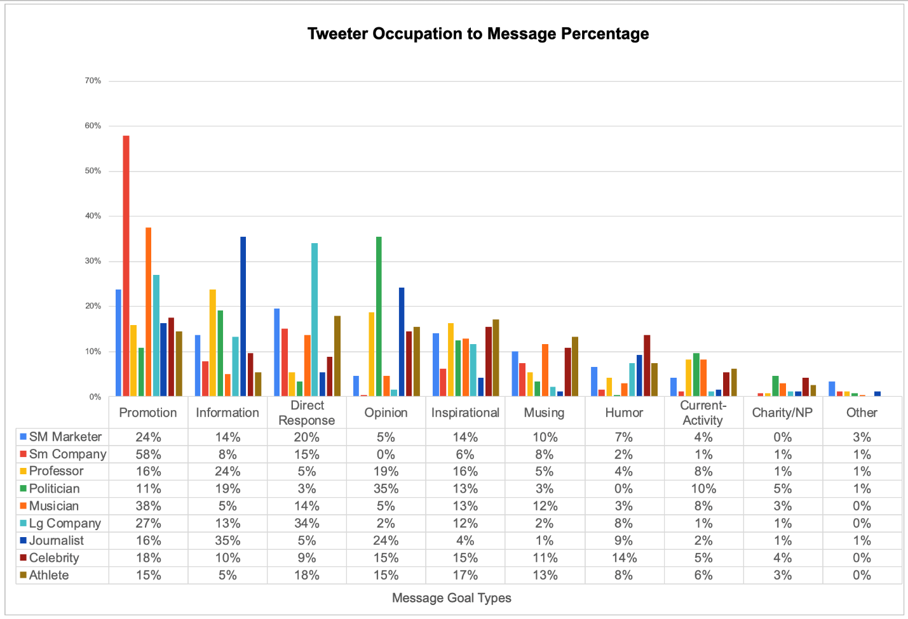

Figure : Occupation to Message Goal

The figure below compares the percentage of message goals overall. This gave us a much clearer ranking of the various goals across all users. Promotion, we noticed, was used 25% of the time overall, information was the second most common goal, followed by direct response, opinion, inspiration, musings, humor, current activity, and charity/nonprofit in respective descending order.

Figure : Prevalence of Message Goals in Overall Data

Next, we separated the data into the two genres, professional and social, to determine how message goals are used collectively by each group of Twitter users. This allowed us to tell at a glance which genre predominantly used each message goal. We then sorted this data in descending order to create the bar graph below, which showed the clear similarities and differences between the two genres.

Figure : Message Goals by Occupation Genre

**EVALUATION:**

Although there were some differences between the two genres in the middle zones, such as the use of opinion or musings, overall, both groups seemed to use Twitter for very similar goals and purposes. For both genres, the most prevalent goal was promotion and the least used was charity/non-profit.

The figure below shows the frequency of the various message goals in two pie charts, highlighting the differences between the two groups.

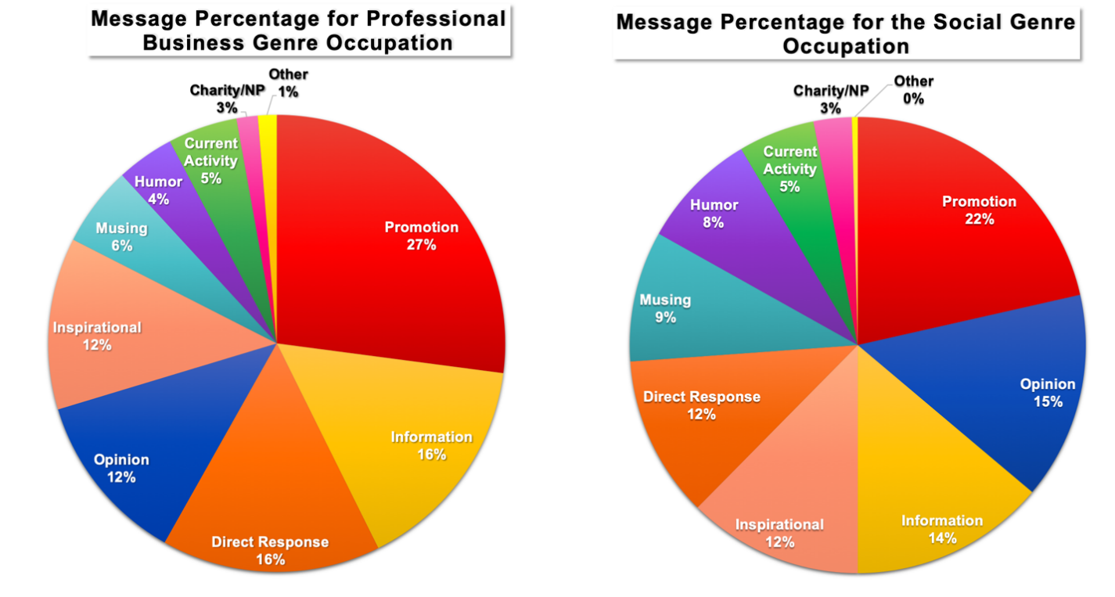 Figure : Message Goals by Occupation Genre

The most prevalent goal types, and who was most and least likely to use each of them is described below.

**Promotion**:

Both groups of users in the study used Twitter primarily to promote, whether themselves, a cause, or someone else. Professionals used this goal slightly more frequently than the social accounts, with 27% of the professionals’ tweets being used for promotion, while only 22%of the more social users used promotion (see Figure 4).

For all tweets across the board, promotion was the number one way that Twitter was used. In all the chatter on Twitter, most people are just crying out – look at me! As Kerpen et al. explain in the appendix of *Likeable Social Media*, most Twitter users are there as a community to “learn, share, and grow.” (Kerpen, Greenbaum, & Berk, 2019, p.283) Following is a chart with an example of a tweet using promotion as its message goal.

Figure 5: Promotion Message Goal Chart & an Example of a Small Company Tweet Utilizing this Goal Type

Small companies were by far the most likely to use promotion – 58% of their posts fell under the category of promotion according to the figure above. This makes sense if you think about the very fact that they are small companies, and would naturally want to promote their brand to create as much revenue and growth as possible. Kerpen et al. wrote about the way small as well as larger businesses can use social media to promote themselves. “Social media provides great outlets for marketing, public relations, and advertising, but it also involves customer service, customer relationship management, sales, operations, human resources, and research and development.” (Kerpen et al., 2019, p217) Politicians, on the other hand, are the least likely to use promotion as a goal; instead they were most likely to use Twitter to share opinions.

**Information**:

Kerpen et al. wrote that “Tweets are a great way to share any industry-relevant information, news, and links…. Sharing information from an assortment of sources builds credibility, trust, and thought leadership.” (Kerpen et al., 2019, p. 283)

Indeed, sharing information was the second most commonly used goal overall, and this goal was used by business professionals slightly more frequently than social users, with business professionals using Twitter for this purpose 16% of the time and social users 14%. (see figure 4) The table below shows the breakdown of how various occupations used this message type.

Figure 6: Information message goal chart & an example of a Journalist Tweet

Journalists were the most likely to use this goal, with 35% of their posts falling into this category. (See figure 6) Probably, journalists use Twitter in this manner because of the very nature of their field. The occupation to use Twitter to pass on information least frequently was athletes, with only five percent of their posts having this as a goal. Instead, athletes were more likely to use direct response, at 18% of their posts. (See figure 1 or figure 7)

**Direct Response:**

As figure 2 shows, the third most common type of tweet we uncovered in this study was direct response. Large companies used this type of message 34% of the time, more often than any other kind of message. (figure 8) In general, the professional genre of users was more likely to use this goal, with 16% of the tweets used for direct response compared to 11% of messages from the more social genres. (See figure 3) Politicians were the least likely to use direct response, with just 3% of their messages being direct responses. The figure below shows an example of a large business direct response, as well as a pie chart highlighting the direct response message percentage to occupation types.

Figure 7: Direct Response Chart & example Tweet

**Opinion:**

The third most common goal for the social genres was opinion, used 15% of the time by these users, but was only used by the more professional genre of users 12% of the time. This message goal was used most by politicians, who used it in 35% of their tweets. The least likely to use this message goal were small businesses, who did not have any reported use of opinions in the study, and second least by large companies, which only used the message goal in 2% of the study’s tweets.

Figure 8: Opinion Goal Chart & example Tweet

**Charity/Non-Profit:**

Of the defined classes of message goals (not other) the least commonly used goal by most users was charity/non-profit. Twitter users from the social genre were slightly more likely to promote charity/non-profit than professionals. Politicians were more likely than any other group to promote charity/non-profit causes, with 5% of their posts being used this way.

Figure9: Opinion Goal Chart & example Tweet

**CONCLUSION:**

As the next graph shows, while there are many similarities between the message goals of the two genres, overall, the trend line which shows the goals used by the more professional genres is somewhat steeper than the trend line for the more social Twitter users, showing that the social users are slightly more likely to use more different message goals than the professional users, and this is what we expected to find. Those who use Twitter as a business professional, we hypothesized, would primarily be using the account to improve their business.

Figure 10: Overall Message Goal Trend

In *Likeable Social Media*, Kerpen et al. noted that “At best, by not listening, you're not leveraging potential opportunities for growth, damage control, or both. At worst, you're causing your customers and prospects to turn to your competitors -- those who *are* listening and will respond to customer needs. You're also allowing your brand reputation to be significantly hurt because, by the time you get around to learning what people are saying, it may be too late to respond efficiently and make necessary changes to keep your company growing.” (Kerpen et al., 2019, p.37) Although social users do not strictly use Twitter to directly interact with people, we all tend to use Twitter to promote ourselves and our personal causes of choice.

Although our findings did conclude that business professionals would most likely use promotion and direct response, we were a little surprised to find that the more social users were also consistently using Twitter for promotion more than any other goal. In the book *So You’ve Been Publicly Shamed*, Jon Ronson wrote about managing your social media brand. He notes “We were creating a world where the smartest way to survive is to be bland.” (Ronson, 2015, p. 139) We believe that Twitter is such a public platform and that people are learning that although they may be posting on Twitter personally, anything they say in their social media accounts – whether personal or business- can definitely affect their professional lives as well as their personal ones, and they appear to be treating their personal Twitter accounts more like a professional user might.

REFERENCES:

Kerpen, D., Berk, Robert E., & Kerpen, Carrie. (2019). *Likeable Social Media : How to Delight Your Customers, Create an Irresistible Brand, and Be Generally Amazing On All Social Networks That Matter* (Revised and expanded third edition.). New York: McGraw-Hill Education.

Ronson, J. (2015). *So You've Been Publicly Shamed*. New York: Riverhead Books, A member of Penguin Group (USA).