Katrina Bilic
DTC 101
Final Multi-Media Essay
7/29/2021
Seeing Both Sides: Instagram and the Effect of Social Media
Introduction:
Social media has become an integral part of many people’s lives. With every cell phone and computer you have the option to download and sign up for an account that connects you with thousands of other users that share their experiences with each other. Whether you are just connecting with a friend from high school or trying to spread the word about your favorite business, social media has allowed access to these things and many more. What makes social media attractive is the use of digital media. Digital media allows the sharing, creating, and experiencing possible in easy and thoughtless ways, making it appealing for people to use. The social media app Instagram has expanded from a simple photo communication app to a place surrounded by likes, shares and now a location for online businesses. Digital media has allowed this expansion to take place.
But it all comes with a cost. These great pieces of communication all have their benefits and disadvantages. It is up to the user to determine how they will use this technology, making “choice” one of its biggest areas of interest. Through analyzing particular parts of the social media service Instagram, the presence of benefits and disadvantages to digital media come across in various ways. All together digital media, in this case in the form of social media has prompted an effect on the culture of today’s world, living in a space where fact is not as simple as it once was, and reality is skewed by an altered sense of truth.

A Brief overview of Instagram:
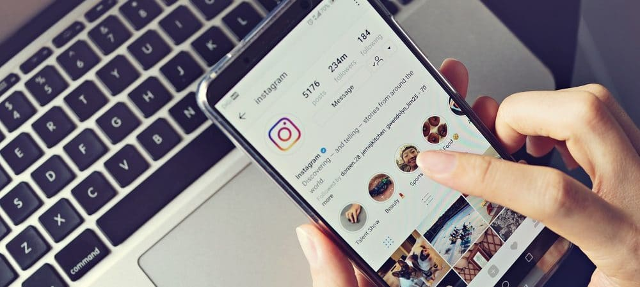
Instagram was created in 2010 as a social media app made for instant sharing of photos. The simple purpose of sharing photos expanded over the years. Instagram today not only offers the ability to like, comments, share, and follow other users and their posts. Users can now use its shopping section to find thousands of online businesses, and even use a “story” ability to share short glimpses into their lives that delete after 24 hours. Live videos and instant messaging were also added to the app, along with face-to-face video chatting. Instagram is a one-stop shop for many of the amenities that social media can offer. All together one can live their life, share it online, and even work from this online social space. What hides behind this application is how it changes our culture of sharing and communication.
Social Media and Culture:
One of the most human things is a desire for communication. Humans are social creatures and it is only more human to use the technology available to expand how one can socialize. Instagram allows for communication to take place and to feed this genetic need for socialization. This form of digital media is beneficial in that it provides humans with a way to communicate, now at a greater scale than ever before. However, along with the benefits come several disadvantages, all together working towards a complex digital culture of our world today.
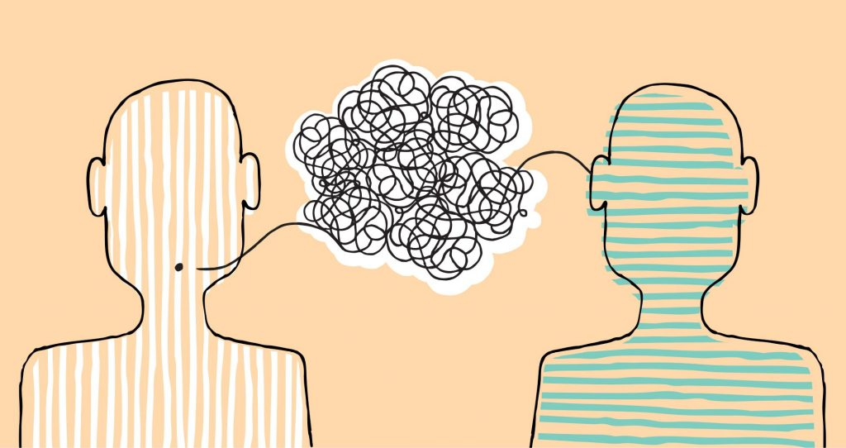
“The very tools that allow for the growth of social networks also presents some of the real dangers that threaten the health of all online communities and the general trust in social discourse” – DTC 101: 05 Social Media
One’s identity is skewed due to the anonymity on these social media platforms. You can never be sure who is actually behind the screen of a user’s page. Instead, you choose to trust these users. One post or profile page does not tell a whole life story, just several glimpses. As mentioned in the DTC textbook, the expansion of social networks allowed for more anonymity in these digital spaces. You do not have to portray yourself, nor do your posts have to reflect real-life experiences. It becomes a matter of trust which the quote above addresses. These tools while great and showcase an improvement in technology, may also have a greater effect on who we become due to the various doors it opens.
In his book Program or be Programmed, author Douglas Rushkoff ties into this idea of identity and anonymity in the digital world. He discusses the idea that users can find themselves using digital means as a place to hide. While “hiding” behind their screens as they lash out or make questionable decisions, it becomes apparent that one’s true colors come out when protected by online anonymity. Rushkoff offers that “We don’t put words into the digital realm unless we are willing to own them” (95). This action is preferred as people can be their true selves online and with social media, but on the other side, digital media may just bring out the part of ourselves we do not want to be seen in physical form. The culture surrounding digital media is changed when real physical people can use anonymity to their advantage, separating themselves from reality.
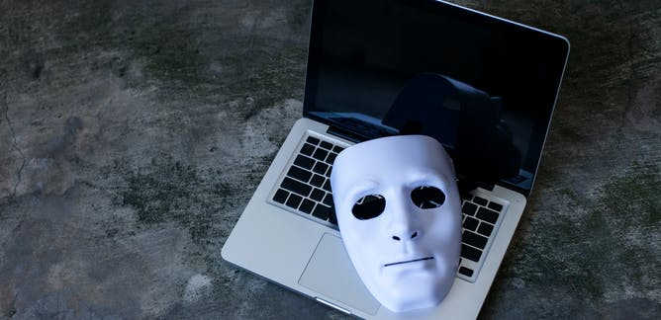
The users must decide what it is they can believe, and what they will take to form their own opinions. With the mass amount of sharing that goes through Instagram, and algorithms that adjust ones feed to issues that may affect them, it is not just personal stories one must interpret. This begins to include real-world news of political and social issues.
We may also lose the physical world through social media. In an app like Instagram, everything is literally at your fingertips. A simple picture shared by someone who went to Yellowstone National Park does not sum up what Yellowstone is. You have to physically be there to experience it. Our digital media simply allows us to capture these experiences and share them visually. Digital media has created a culture where our space is lost. If we are in the digital media space, our outside portrayal is disregarded, the same can go for the outside world.
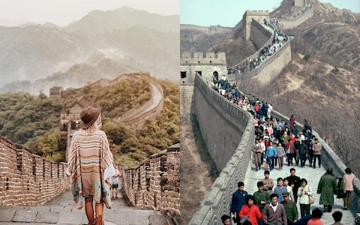
The Medium:
“All human technologies extend some function of the body” – DTC 101: 02 Digital Media
The idea of media being an extension of the human body is something McLuhan offers in his work. Digital media is no different as it is simply “an extension of the nervous system”. Because this technology exists as an extension of ourselves, we are connected to it in ways we may not see. Certainly a point of interest when discussing an attractive piece such as social media. Social media gains control of the medium through an intelligent interface that allows for ease of use while feeding users with what they crave so deeply: communication. With McLuhan’s observations, the medium is a part of our new digital media to be attentive to. “The medium is the massage” is a popular point for McLuhan, which Instagram follows. The pleasing and clean aesthetic makes it easy to use and understand, while the simplicity of sharing pictures in a timeline for scrolling leads to hours spent on the app.
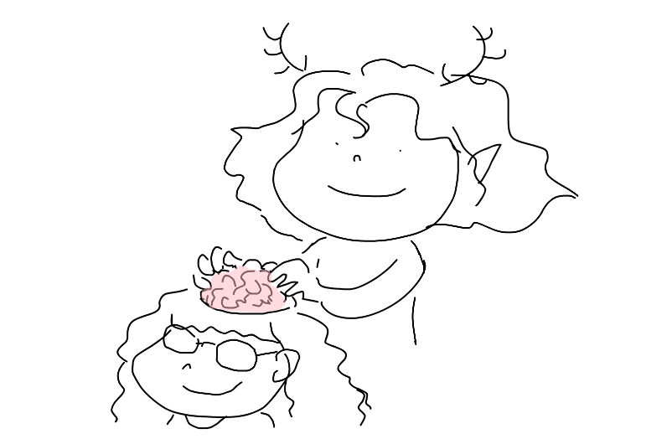
The benefit of this medium in social media is that it pleases users. It gives them the communication they so crave, it “massages” the mind due to its pleasing aesthetic, and allows users to “escape” in hours of scrolling. The medium itself describes how far technology has come and allows for so much more than basic communication. In one application the user can take advantage of several principles of new media. Automation is found in the use of thousands of filters to use on a picture, allowing for many ways to remix your work into something new. Variability is present through the ability of people to take an object off of their feed and edit it into an infinite number of variations. Not to mention the numerical representation factor that allows for data to be used in algorithms that adjust a user’s feed and app experience.
There is a flip side to each benefit offered through these apps. Unfortunately, everything that has a good use also has a negative one in the hands of the wrong person. With such an addictive interface that is given through a medium like Instagram, people can take advantage of this for their benefit. Truth becomes skewed as people use the app to gain attention towards false ideas. Rushkoff refers to these types of things under his sections of truth and social. People use social media for monetary gain, all it takes is simply posting a picture of a product and a false review of said product to gain something. The users must once again choose to believe anything they see on this type of media. There will always be truths, but lies are not far away. We must remain true to ourselves when deciding what we believe, even when the medium we are absorbing so desperately wants us to fall into the lies.
Conclusion:
Social media has changed many things about our digital media culture today. It has introduced serval different aspects to how we see the world around us, and how we choose to interpret it. But it is the way of today to use digital media to tell stories and communicate with others. In the form of social media, our communication is expanded in several different directions and choice is heavily involved with this. The examples of benefits and disadvantages as highlighted in the above essay illustrates one major thing about the culture of digital media and that is balance. We as users and participants in this digital world must balance the good and the bad of our new technology. We can make conscious decisions in how we want to use the tools given to us. The world of digital technology and social media has changed several things for how we interact with each other. What remains is our ability to choose how we use the technology and allow it to use us. A Balance between benefits and disadvantages must be given attention if we want to keep our ability for choice in the new digital world.

Sources Used
Readings and Textbook:
Program or be Programmed by Douglas Rushkoff (95)
DTC 101 Textbook: 05 Social Media by William Luers
DTC 101 Textbook: 01 Digital Media by William Luers
The Medium is the Massage by Marshall McLuhan
Photos:
Instagram Interface:
https://olhardigital.com.br/en/2021/05/27/tips-and-tutorials/instagram-know-how-to-show-or-hide-likes/
Two heads communicating:
https://crestcom.com/ca/blog/2018/12/18/listening-better-leadership-qualities/
Online Mask:
https://theconversation.com/us/topics/online-anonymity-8035
Instagram vs. Reality:
https://www.telegraph.co.uk/travel/news/Instagram-vs-reality-how-travel-photos-are-a-lie/
Brain Massage:
https://www.sketchport.com/drawing/5938863105114112/brain-massage

