Vitaliy Kononenko
DTC 101
February 16, 2013
@v_kono

Smartphones & Remediation
Remediation is defined by the dictionary as the action of remedying something. The root word remedy is something that corrects or removes an evil of any kind (Dictionary). While the computer interface did not have any sort of evil, smartphones have most definitely remediated the computer interface and interactivity, in my opinion, for the better.
Before the introduction of the first iPhone in 2007, technology was slightly more complicated than it is in the present. The iPhone brought a much simpler, user friendly user interface that could be used by essentially anyone with their five stylus-like fingers. Steve Jobs described the iPhone as having a “Revolutionary UI”. It was an interplay of software and hardware. The question was why did we need a new user interface? Smartphones were already around, so what was the problem? The answer is optimization. Smartphones with keypads were limited. The multi-touch technology that was introduced with the iPhone granted access for optimization in every aspect of the phone. The iPhone was a game changer. The software was a mobile form of the already world renowned Mac OS X operating system. It had most of the essential features of a standard Macintosh running Mac OS X. The idea was to bring something appealing to the consumer that was in a simple form of a complex operating system and bring it into a mobile device.
If you’ve been following the patent war between Samsung & Apple, you may have seen the following image (see Figure 1). Other manufacturers saw a great interest in Apple’s design. Many companies entered the market and began producing multi-touch devices too. Samsung, HTC, Motorola, Nokia, Sony, and LG were just a few of the many. Microsoft was one of them. Their device, the Windows Phone was released in late 2010. A multi-touch device running a mobile version of Microsoft’s popular Windows operating system. Live tiles and the big buttons made it easy for anyone to adapt to the mobile version. Bear with me here. I will return to Microsoft shortly.
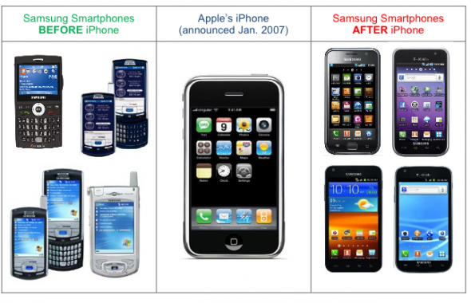
Figure 1

As the years went by, Apple saw a phenomenal and overwhelming response to their mobile operating system, the iOS. When Apple announced the newest OS X in 2010, they decided to bring some of the things they learned from the iOS and bring it back of the OS X. OS X Lion was born. Ironically, it was unveiled at an event called “Back to the Mac”. OS X Lion brought back many developments from the iOS mobile operating system, such as the Launchpad. It was a place where you could see all the installed programs similar to the home screen on the iPhone. If you wanted to see the next page, a simple swipe on your trackpad took you there. It was amazing. Many of the features, such as multi-touch gestures, sparked interest in many consumers. The OS X operating system was already amazing, and the latest version of the operating system made it even more amazing. And then OS X Mountain arrived. The world’s most advanced operating system as referred by Apple. It brought the iCloud service to the Mac and almost all of the features that shipped with iOS 5 just a year before. Over 200 features now on your Mac and synced up with your iPhone, iPod, or iPad.
Now back to Microsoft. I feel like Microsoft caught onto what Apple was doing. Their mobile version of their operating system, Windows, brought some competition to the table. And that is when Windows 8 was born. Windows 8 introduced significant changes to the OS by improving the user experience to better compete with other operating systems. The touch-friendly live tiles, simplicity, and features like the Windows Store were incorporated into the operating system. Like Apple, many of these features were brought in from their mobile version of Windows found on the Windows Phone. With Windows 8 being so touch-friendly, many PC manufacturers began producing a large quantity of touch-screen notebooks and all-in-one desktop PC’s that ship with Microsoft’s latest creation, Windows 8. An article titled “Immediacy, Hypermediacy, and Remediation,” Bolter and Grusin say that remediation “ensures that the older medium cannot be entirely effaced” (79). Windows 8 still depends on its roots for operation. It still holds some of the core values of the original version of Windows. It has been completely remediated to stay fresh.
Bolter and Grusin point out that it is the intention to make the computer interface more natural (67). The genius and design that is going into making the computers more native is just stunning. My opinion is that the industry is going into the right direction. With the tablet market emerging and taking a large share of the PC industry, it is the idea of many people that tablets will soon replace the personal computer. When the iPad was first introduced, it was created to fill the void between the smartphone and the PC. It was like neutral ground. The original idea was not to replace the PC. It was more like another option for the user. With the popularity of the iPad and many other competitors, the world is slowly shifting from the PC to the tablet. Tablets are mobile. While they do not support a lot of the operations that you can do on a PC, they still seem to be in high demand.
In conclusion, smartphones have greatly impacted the computer interface. We have seen how the mobile operating systems on smartphones are slowly being incorporated in the complete PC operating system experience. We interact with computers with touch, rather than a mouse. The simplicity of the operating systems and the incorporation of many cloud services keep us connected. The computer won’t go away. Tablets won’t destroy computers. The course is set. If it is followed correctly, the computer interface and the way we interact with computers will become even more natural than it has ever been before.

