***Call of Duty: Black Ops 4***

The company known as Treyarch didn’t come about until 1996. Prior to that period in time its flagship company Activision had been doing very well for itself and as a result Treyarch was created to meet the demand for faster releases and more released games in the years to come. Treyarch studios is a subsidiary company of video game publisher Activision. The company initially included David Crane and Alan Miller who left Atari in 1979 after a dispute regarding royalties. Later they were joined by fellow designers Larry Kaplan and Bob Whitehead under the direction of entertainment executive Jim Levy (Account, Treyarch). In 2003 prior to the release of the first Call of Duty Activision purchased Infinity Ward solidifying what would later secure its place as one of the largest video game companies. Founded as an independent game development studio in 1996 by Peter Akemann and Don Likeness under the wing of Activision created the Call of Duty: Black Ops series which dedicates much of its success to innovative contributions such as zombies which were implemented after legal disputes following the original release of Nazi Zombies in Call of Duty: World at War (Treyarch Company).

The major goal of Treyarch for this campaign is to bring awareness to their campaign in order to create a successful Black Ops series game and its partnership with Activision which combine to create a thriving industry. One of the major goals of this campaign is to bring attention as well as hype to the newest innovation by Treyarch in the form of their take on the Battle Royale genre known as Blackout. Another goal on Treyarch’s part is to bring back diehard fans, as well as fanboys of the Fortnite, and games like that of PlayerUnknownsBattleground (PUBG) to the Call of Duty series (Activision About Us). From what I gathered the primary social medias are Twitter, and Youtube in that order with David Vonderhaar being something of a media sensation, he is commonly referred to as Lord Vonderhaar (Account, Lord).

As I began to dig into what Treyarch really is I obtained some insight into the inner workings of one of the largest video game companies today. As I learned Treyarch falls under a large list of subsidiary companies overseen by Activision, a company known for its wide player base and even larger fanbase. Call of Duty: Black Ops 4 was revealed May 23rd via a broadcast on twitter and had over 80million live streamers. The game released on October 12th, so roughly 5 months of social media coverage and will dwindle at a steady pace following the game’s release. This is due to the retention rates and complaints about in game details as much as it is due to the fact that shortly after this game releases another social media awareness is usually raised with downloadable content (DLC) which is produced every 4 or so months to keep saturation full (Ray, Michael). For the purpose of this campaign we will focus on the growth and success in terms of social media by looking at the Twitter, SocialBlade, and stock data in order to understand how Treyarch ousted Epic Games’ number one game, Fortnite.

The market segmentation is a large mix of demographics and Activision caters its games to a wide audience that ranges from teens and children albeit the game rating is usually M for Mature. They also cater towards adults, and often try to take it a step further by releasing content for the social media campaign on the weekends so they gain the most retention. Another group that they appeal to is women, as I learned this is the fastest growing gaming group in America. For economics they tend to target middle to lower class people as these are the people most likely to play them. This is due to hard jobs, limited quantities of cash and of course spare time when they aren’t working. As far as geographic demographics go it seems that this franchise targets first world countries with the United States making up a large portion of their western hemisphere sales (Activision Acquires).

Something I encountered throughout the years is that Activision counts on the fact that when they release additional content for their games that people will buy it up resulting in further sales, players getting back into the game and of course expanding the number of players joining the community. However, they don’t capitalize on key points like linking the company’s websites or showing who the director is, as you mentioned in class they aren’t utilizing some of the basic concepts to reinforce their product or to increase their exposure to their audience which is fragmented between developers such as Treyarch, Infinity ward, Sledgehammer games, Ravensoft, and Visceral games.

Treyarch’s use of social media is somewhat limited to promotional advertisement, as well as retainment purposes. They do however utilize David Vonderhaar’s wide audience reach to relay information. For those of you who don’t know David Vonerhaar is the creative design director at Treyarch and is rather comedic in his Tweets which range from sassy to downright cruel. As an example of his latest shenanigans is this reddit post,

<https://www.reddit.com/r/Blackops4/comments/9tje4d/i_hate_my_life/>. This is a good example of how Treyarch stays in touch with the audience and utilizes their employees’ own personalities to make their campaign more marketable. This relates back to Treyarch’s founding, and ties into their parent company Activision. To bring it full circle Vonderhaar creates publicity which increases their market reach, saturation, and of course results in more sales. However, Treyarch follows the social media marketing pyramid which focuses more on ensuring people see the advertisements and know of the product rather than direct sales.

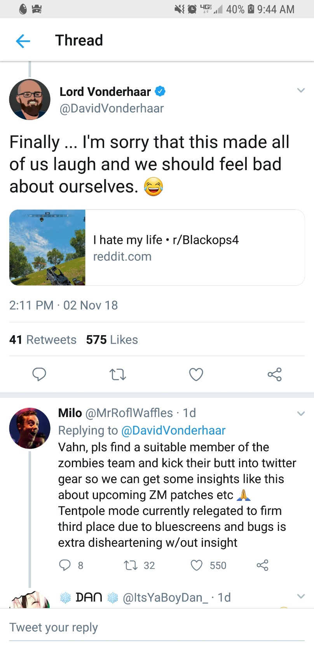

The above screenshot shows Vonderhaar’s schenanigans first hand. Within two days he had a few hundred comments, almost 600 likes, and 23 retweets. This image is important because it shows just how dedicated the overall Treyarch team is about getting their audiences feedback and implementing improvements to their product.

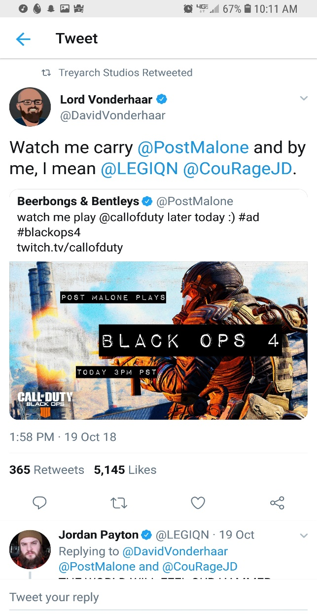

This image came from [Twitter](https://twitter.com/DavidVonderhaar?ref_src=twsrc%5Egoogle%7Ctwcamp%5Eserp%7Ctwgr%5Eauthor) and includes more gaming sphere celebrities.

David Vonderhaar is undoubtedly the reason that the #CODE4Vets, and #CODNATION sub campaigns were created. By being active with the community and interacting with unique followers such as Post Malone, Lil Yachty and YouTube sensations like CouRageJD, NinjasHyper, as well as DrLupo these campaigns gain major followings. For those that don’t know CouRageJD is a major league gamer as well as a Youtuber who is known for his use of game footage and cryptic tweets. As another big Youtuber NinjasHyper is believed to be the highest paid gamer bringing in roughly $1,000,000 annually. Although his following isn’t as big DrLupo can often be found playing with NinjasHyper, he is rather comedic, but rather than use YouTube Lupo utilizes TwitchTV.

YouTube ensures that the audience can feel involved and see the fruition of the labors that Treyarch seeks to sow. At the beginning of the #BlackOps4 campaign there was little to no content and that included YouTube, Twitter, or Twitch TV. After a few months this number rocketed to a dozen videos which ranged from short video trailers to concept art. At the peak time there were a dozen uploads within a few days and as aforementioned included rap artist Lil Yachty, later Post Malone, and countless YouTube and Twitch stars.

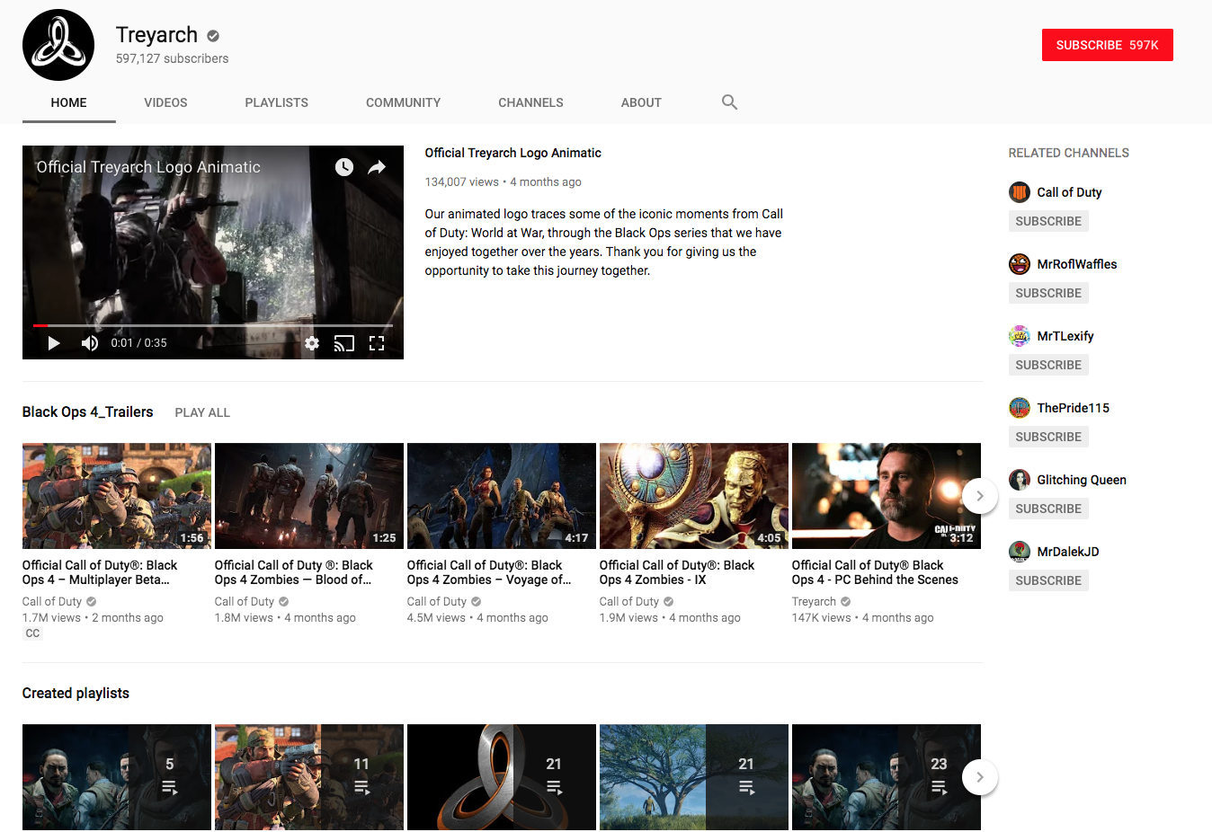

As you can see in the image from [YouTube](https://www.youtube.com/channel/UCszIOrsb8PSapcRdsnGn1FA) Treyarch is efficient at cleaning up old videos to make room for viewers to find the new ones.

SocialBlade is the analytics I used to measure the success of Treyarch’s campaign. It supplies data that ranges from daily views, daily subscribers, and approximation of ad revenue. This allowed me to track how successful the campaign was over the last month as well as day to day. With this data I can isolate and connect specific posts or uploads to the success of the campaign whether that is through their daily, monthly, or yearly subscriber gains. If this doesn’t do it then I can focus on their generated ad revenue, or perhaps their overall views for each of these videos. And finally if that doesn’t warrant the results we’re looking for then perhaps the overall comments on each video would suffice, afterall a successful social media campaign warrants interaction between the author of said campaign and the fandom of said author.

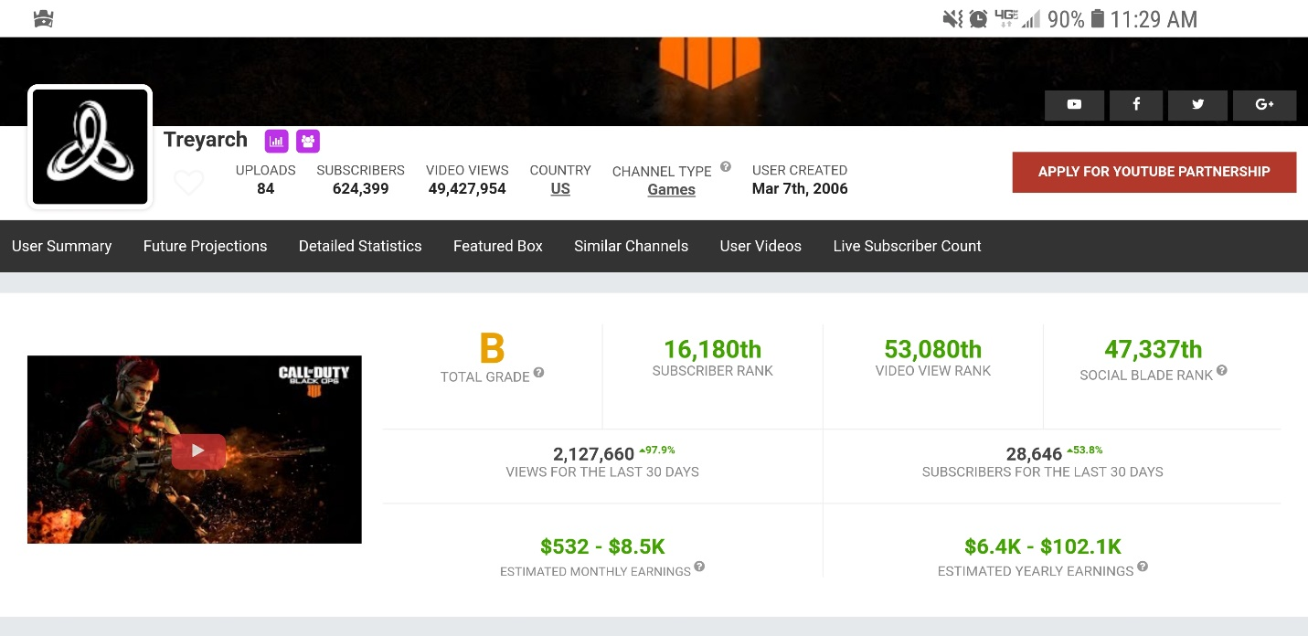

This image was taken from [SocialBlade](https://socialblade.com/youtube/user/treyarch) and features a unique grading system which places each of these profiles into a list based on the number of subscribers, video views, and yearly earnings as shown above and then assigns them a grade based on their overall rank. It wasn’t that shocking to learn that the #1 profiles are actually genres such as rap music, or animal videos but don’t actually have any videos posted.

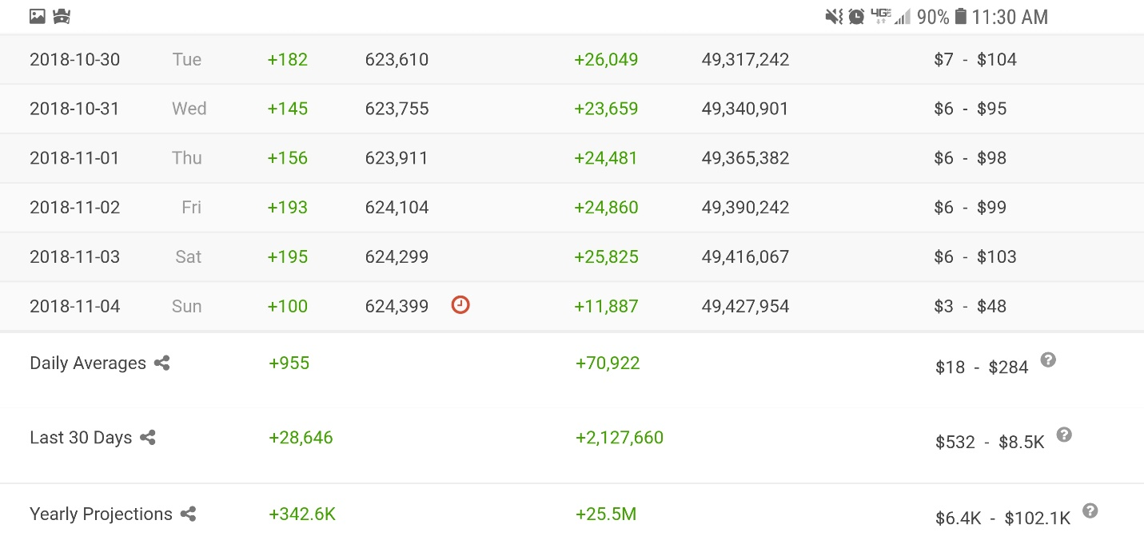

As mentioned above this shows how SocialBlade can track any YouTube, [Twitter](https://socialblade.com/twitter/), [Instagram](https://socialblade.com/instagram/), [Facebook](https://socialblade.com/facebook/), and even [Twitch](https://socialblade.com/twitch/) statistics. As you can see within the last week Treyarch has gained 971 subscribers and had 136,761 views generating between $34-547 on their main channel alone.

Based on the statistics I gathered from SocialBlade this campaign seems to be not only successful but also thriving enough that they did multiple small campaigns within it. Although in this report I only used SocailBlade for YouTube it shows how Treyarch uses metatags to garner more views which result in more subscribers in order to make more money. It also shows that as updates and changes are made to the campaign whether that is in the form of game content in this case, or even interaction or lack thereof with the viewers can result in a loss of subscribers.

As seen on the NASDAQ Treyarch has had it’s gains and losses, but the overall trend after the creation of #BlackOps4 in May was on a positive trend until CNBC’s stock experts predicted Epic Games’ Fortnite would beat out Treyarch. In part this is due to Fortnite being a free game, and Epic Games’ abuse of lenient laws and regulations of video games that are still in the Beta stage. The beta stage is when a game is tested extensively to eliminate any bugs in the game as well as glitches or errors. Yet a few months later Treyarch’s #BlackOps4 has beat out Fortnite and continues to sell after breaking records for most sold digital game in Sony history, most sold Call of Duty game both physically and digitally, and it set records for most sales within a 24-hour period.

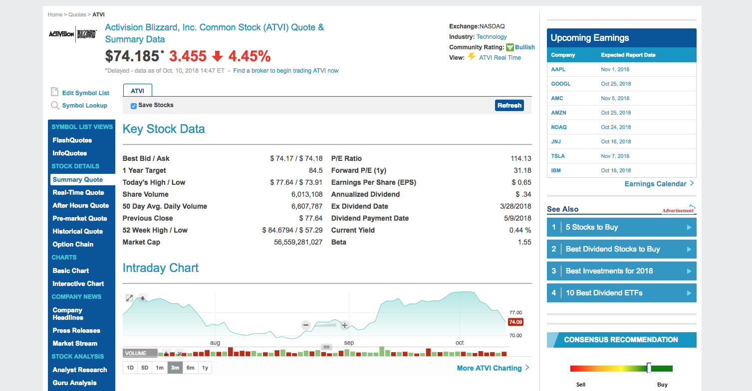

This image was supplied by [NASDAQ](https://www.nasdaq.com/symbol/atvi) and is featuring a 3 month period that highlights August, September, and October but actually spans from May when the game was announced until mid-October when the game was released. During this report it’s assumed that this campaign hasn’t actually finished as of the release of the game as some campaigns do.

This image is relevant because it shows the gradual incline of the company that owns Treyarch which is Activision. At the time of the screenshot the stock was down 4.45% this is believed to be because of a post by CNBC in which stock experts outlined the chances of Fortnite a game created by Epic Games would beat out Treyarch’s new game. However, as the following screenshot shows the stock has made a steady rebound and looks to continue to do so until the next Battle Royale game threatens it for the #1 position.

Overall the stock prices have the most straightforward results for this campaign. Aside from the $380,000 raised for Veterans, and all of the records broken by this game it’s hard to refute the fact that its stocks have increased in value since the start of this campaign and the release of the game which itself secured millions of dollars for the companies involved. The biggest weakness for this campaign was itself, but by including a variety of big named Twitter and otherwise famous people Treyarch established a larger fandom while boosting sales and promotional advertisement through these people.

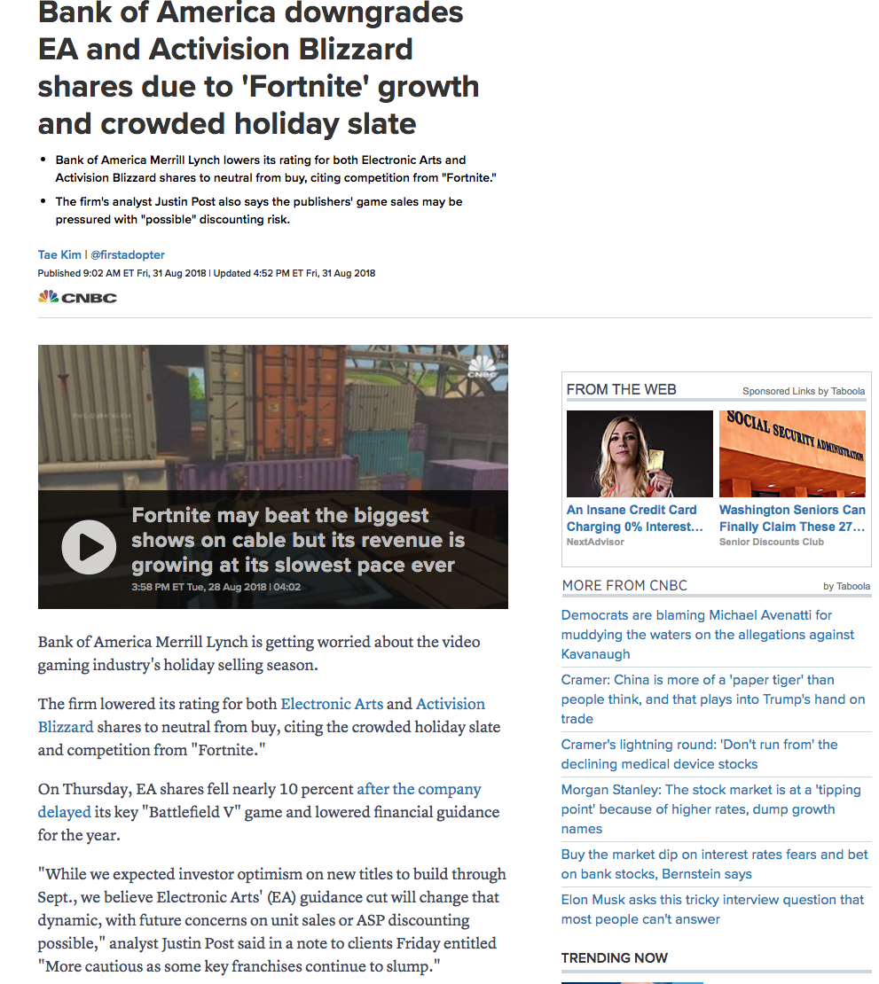

This image was brought to you by [CNBC](https://www.cnbc.com/2018/08/31/bank-of-america-downgrades-ea-activision-blizzard-due-to-fortnite.html) and features an article regarding EA’s game delay, and mentions how Treyarch is predicted to lose sales due to holiday sales and competition from other games that release around that time.

There were a few hitches while researching Treyarch to mention a few the amount of data that stems from a video game publisher of major AAA titles like the Call of Duty franchise was a fun challenge. Further, these companies will not publish their quarterly results until after this is completed. In order to garner a current estimate, I used SocialBlade as aforementioned.

Although I knew going into this campaign that there would be a large volume of data to sift through it turns out that the number of individual accounts necessary to track all of the data was harder to obtain. Albeit after some digging it seems like the two major accounts for Treyarch are David Vonderhaar and their #BlackOps4 profiles. Another issue was getting a general consensus on the success of a campaign that split into multiple smaller campaigns which could be measured, for example the #CODE4Vets campaign as I mentioned earlier made $380,000 to be used in placing veterans in jobs. Another sub-campaign was #CODNATION which didn’t fundraise but instead focused on getting views and had millions of views each, part of this is cross-platform views as Lil Yachty, and Post Malone bring their own subscribers to the channel to see them in advertisement videos.

Even these smaller campaigns were a major success with Lil Yachty and Post Malone receiving more views after this and Treyarch not only gaining more followers but also demonstrating they’re inclined to allow musical artists to participate in their social media campaigns. Some background on the inclusion of artists in the COD series major artists such as John Dankworth, Full Tilt, Alexander Alexandrov, Sergey Mikhalkov, Blues Saraceno, Wolfgang Amadeus Mozart, Johann Gottfried Piefke, Cliff Lin, Eminem, P!nk, The Rolling Stones, Keith Mansfield, 45 Grave, The Tokens, Celia Cruz, Matt Hirt, Avenged Sevenfold, AC/DC, and [many more](https://www.musictimes.com/articles/14749/20141106/call-duty-trailer-soundtracks-frank-sinatra-eminem-ac-dc-more.htm).

After reviewing the individual components which included various social media platforms such as Twitter, SocialBlade, YouTube, and NASDAQ the stock exchange it seems evident that this campaign was a success both economically and socially. Although this doesn’t come as a surprise since Treyarch has been producing AAA titles for the COD series for the better part 23 years. Although many social media campaigns stem from this major one the most debated statistics are the analytics which show raw data as well as compilations of month to month or estimates but in the case of Treyarch’s #BlackOps4 even without quarterly data or economic numbers gathered from the NASDAQ both the community and viewers can see that their saturation and retention rates are great. If you have any questions or comments, please feel free to send them to me at Dimitri.myers@wsu.edu.

Works Cited

Account, Lord VonderhaarVerified. “Lord Vonderhaar (@DavidVonderhaar).” *Twitter*, Twitter, 22 Sept. 2018, twitter.com/DavidVonderhaar?ref_src=twsrc^google|twcamp^serp|twgr^author.

Account, Treyarch StudiosVerified. “Treyarch Studios (@Treyarch).” *Twitter*, Twitter, 25 Sept. 2018, twitter.com/Treyarch?ref_src=twsrc^google|twcamp^serp|twgr^author.

“Activision Acquires Infinity Ward Developer of Critically Acclaimed PC Game Call Of Duty™.” *Activision Blizzard, Inc.*, Activision, investor.activision.com/news-releases/news-release-details/activision-acquires-infinity-ward-developer-critically-acclaimed.

“Activision | Home.” *Activision | About Us*, Activision, www.activision.com/.

“Black Ops 4.” *Call of Duty®*, Activision, www.callofduty.com/blackops4.

“Call of Duty®: Black Ops 4.” *PlayStation*, Sony, www.playstation.com/en-us/games/call-of-duty-black-ops-4-ps4/.

“Official Treyarch Logo Animatic.” *YouTube*, YouTube, www.youtube.com/channel/UCszIOrsb8PSapcRdsnGn1FA.

Ray, Michael. “Activision Blizzard, Inc.” *Encyclopædia Britannica*, Encyclopædia Britannica, Inc., 24 Nov. 2014, www.britannica.com/topic/Activision-Blizzard-Inc.

“Treyarch.” *Facebook > Treyarch*, Facebook, www.facebook.com/Treyarch/.

“Treyarch (@Treyarch) • Instagram Photos and Videos.” *Instagram > Treyarch*, Instagram, www.instagram.com/treyarch/?hl=en.

“Treyarch (Company).” *Giant Bomb*, Giant Bomb, www.giantbomb.com/treyarch/3010-1488/.

“Treyarch > Official Site.” *Treyarch > About Me*, Treyarch, www.treyarch.com/.

“Working at Treyarch.” *Treyarch*, Glassdoor, [www.glassdoor.com/Overview/Working-at-Treyarch-EI_IE330764.11,19.htm](http://www.glassdoor.com/Overview/Working-at-Treyarch-EI_IE330764.11,19.htm).

https://www.musictimes.com/articles/14749/20141106/call-duty-trailer-soundtracks-frank-sinatra-eminem-ac-dc-more.htm