**Project 2:**

**Evaluating a Video Game through the Lens of *Elements of Game Design***

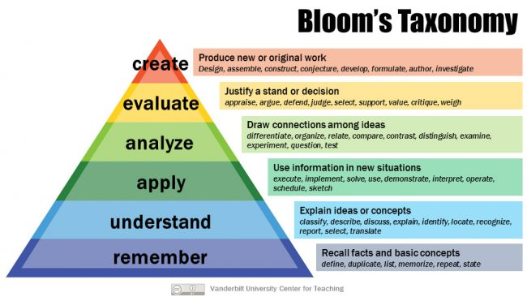

**Overview**

We continue with leveling up in the Bloom’s Taxonomy model with Project 2. Project 1 focused on 4th level, or “Analyze.” Project 2 will focus on the 5th, or “Evaluate.” The activity you will undertake, therefore, asks you to “[j]ustify a stand or decision” and to be able to “appraise,” “argue,” “defend,” “judge,” “select,” “support,” “value,” “critique,” and/or “weigh” a stance about one of the video games featured in our book that you did not discuss in the previous project. It requires you to read reviews that others have written about the game and situate your views within theirs, thus adding new and valuable insights into an understanding of the game.

**Directions**

Step 1: Choose any videogame featured in *Game On!.*

Step 2: Find and read two reviews about the game written by others for a prominent newspaper, journal, or magazine. One of these reviews must reflect views you do not hold about the game and so requires you to make an argument in support of your own.

Step 3: Write a 350-500-word review about your game, drawing in the information gleaned from the other reviews you read and any other information you wish to use in support of your own views.

Step 4: Add your review in the book of reviews that we will produce and publish on the Scalar platform.

**Essay Directions**

This is a formal paper. This is not an exercise. You will turn in a well-thought out and executed essay, 350-500 words in length. You must type it. You must title it something other than “my paper,” “essay on . . .”, etc. You must use 12 pt. type either Arial or Times New Roman. You must run it through spellcheck and grammar check. You must cite from our two books and include them in your Works Cited. You must include any other work you cite in your Works Cited. You must turn the essay in on time. You must put your name on the essay page. You must name the file with your last name and project 1 like this: smith-project 2. You must upload it to the Basecamp folder called Project 2.

You will also turn in a second version of this paper that has been saved as plaintext in a program like Text Wrangler, BBEDit, or some other text editing format. This is the version that we will use for uploading to the Scalar book.

**Due Dates**

The essay (both formats) is due on Friday, November 20, at 11:10 in the Project 2 folder in Basecamp before class begins at 11:10 a.m.