**Project 3:**

**Creating a Video Game through the Lens of *Elements of Game Design***

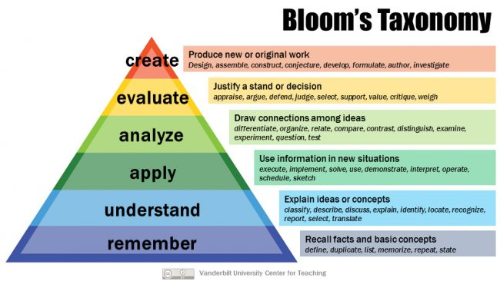

**Overview**

We complete leveling up in the Bloom’s Taxonomy model with Project 3. With Project 1 you moved to the 4th level, “Analyze,” and with Project 2 you advanced to the 5th, “Evaluate.” Project 3 takes you to the 6th level, “Create,” where you will “[d]esign,” “assemble,” “construct,” “conjecture,” “develop,” “formulate,” “author,” and/or “investigate.” Specifically, you will create a new scene for *Tomb Raider*.

**Directions**

Step 1: Study Tomb Raider by playing it/watching playthroughs of it, reading about it in *Game On!* and *Lara Croft: Cyber Heroine*, and reviews of the game.

Step 2: Develop a new scene for the game.

Step 3: Write a 350-500-word game concept (See *Elements of Game Design*, pp. 287-293 about your scene that includes elements you should consider for a game idea and for the market of the game.

Step 4: Be ready to share your project with the class via Zoom on the last day of class.

**Essay Directions**

This is a formal paper. This is not an exercise. You will turn in a well-thought out and executed essay, 350-500 words in length. You must type it. You must title it something other than “my paper,” “essay on . . .”, etc. You must use 12 pt. type either Arial or Times New Roman. You must run it through spellcheck and grammar check. You must cite from our two books and include them in your Works Cited. You must include any other work you cite in your Works Cited. You must turn the essay in on time. You must put your name on the essay page. You must name the file with your last name and project 1 like this: smith-project 3. You must upload it to the Basecamp folder called Project 3.

You will also turn in a second version of this paper that has been saved as plaintext in a program like Text Wrangler, BBEDit, or some other text editing format. This is the version that we will use for uploading to the Scalar book.

**Due Dates**

The essay (both formats) is due on Friday, December 18, at 11:10 in the Project 3 folder in Basecamp before class begins at 11:10 a.m.