Dimitri Myers & Grace Rouleau
DTC 478
4/01/20
Project #9
After reviewing Ling Valentine’s website, the deliberation was made to simplify her site. In order to better accommodate her audience, we created a mobile-friendly prototype of her navigation system. As noted by Nick Babich “Strong visual signifiers (such as contrasting colors for call-to-action buttons) are used to direct user on certain interactive elements or essential information.” (Babich, Nick) So by implementing both contrasting colors as well as directing users in a linear fashion through the site the overall functionality of the sight is improved from her rather cluttered website.
By keeping the same brand identity, we ensure that users connect with the familiarity of the site. According to Raluca Budiu, “Another important issue that is still not well understood by designers is that mobile content needs to be layered.” (Budiu, Raluca) While ensuring that information is streamlined is crucial and the page being responsive helps the website work smoothly, there is another aspect that takes precedence. That is ensuring that users flow from one page to another without hinderance, this ensures a more enjoyable experience and allows them to muddle through until they can satisfice their goal.
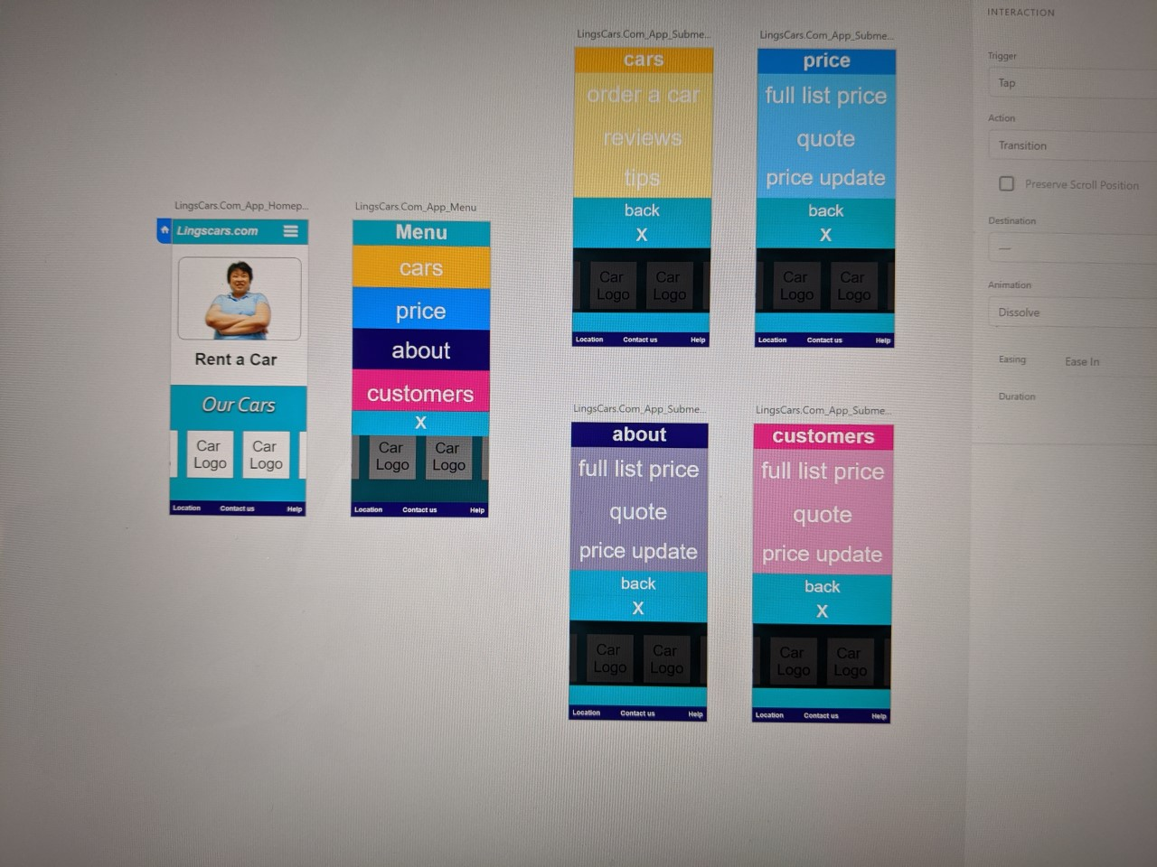
(Image Courtesy of Grace Rouleau)
Although Ling’s website was very popular, it was not updated to reflect modern practices, nor was it very easy to navigate. As stated by Sophia Matveeva, “The user experience and design journey is neverending, because user tastes and technologies are constantly changing.” (Matveeva, Sophia) In order to bring the website up to date, the use of single pages with a dropdown hamburger navigation menu creates a mobile dynamic that flows while still retaining the integrity of the original site.

Works Cited
Babich, Nick. “12 Mobile UX Design Trends For 2018.” Medium, UX Planet, 12 Dec. 2018, uxplanet.org/12-mobile-ux-design-trends-for-2018-5b4ce7e8445f.
Budiu, Raluca. Progress in Mobile User Experience. Nielsen Norman Group, 22 Mar. 2015, www.nngroup.com/articles/mobile-usability-update/.
Matveeva, Sophia. “Product Design Journey: From Idea to Prototype to Live App.” Forbes Magazine, Forbes, 30 Oct. 2017, www.forbes.com/sites/sophiamatveeva/2017/10/27/product-design-journey-how-we-went-from-idea-to-prototype-to-a-live-app/#2276255332e2.
Valentine, Ling. Personal & Business Car Leasing. LINGsCARS, www.lingscars.com/.

