Dimitri Myers & Grace Rouleau
DTC 478
04/08/20
Project #10:
As times change, so too should the usability synonymous with mobile applications. By creating an application that not only acts as a map but also as a virtual tour of downtown Vancouver this application seeks to accommodate the need for better usability. According to Emily from JustInMind, a reputable UX design company “It’s bad practice to simply transform a traditional desktop website into a mobile site. And, according to Nielsen Norman Group, mobile usability is catching up with desktop.” (Adiseshiah, Emily) Furthermore, the mobility associated with phones and other portable devices has left traditional navigation somewhat lacking. Often users are greeted by a generic map that requires a search in order to access additional information. However, with this design the user can choose between a few different options.

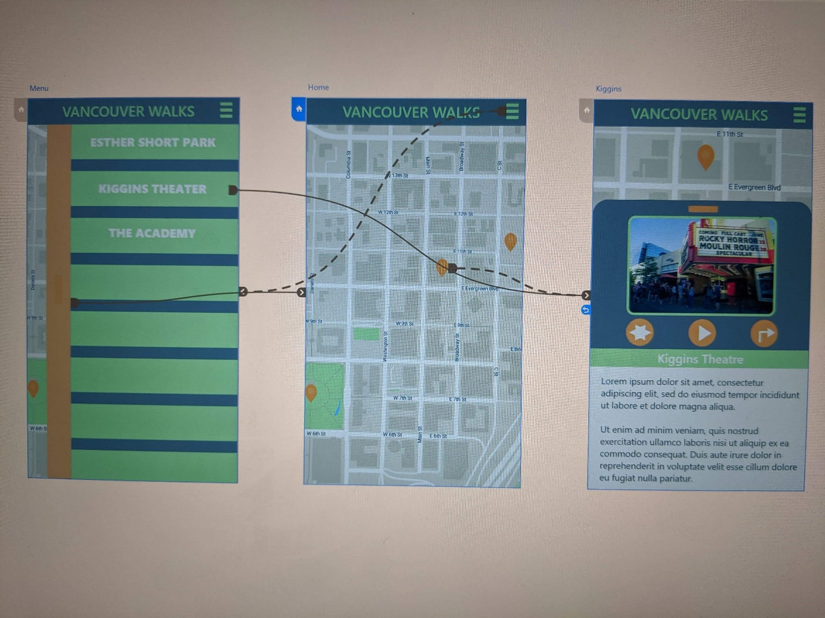
(Image courtesy of Grace Rouleau and created in Adobe XD)
This system is known as the Trifecta. It utilizes traditional navigation, as well as two alternative methods. Based on Anton’s 10 Best Practices for mobile UX design “There are weighty reasons to provide some [different options]. Firstly, it gives room for choice and/or improvement. Secondly, there is a chance to compare estimates for each option.” (Rudenko, Anton) By using the standard method of navigation users are familiar with how it works. Yet the Trifecta introduces pins that automatically activate within a certain distance to the location, allowing you to walk to it or choose to read about the location and then navigate to its location to see it for yourself.
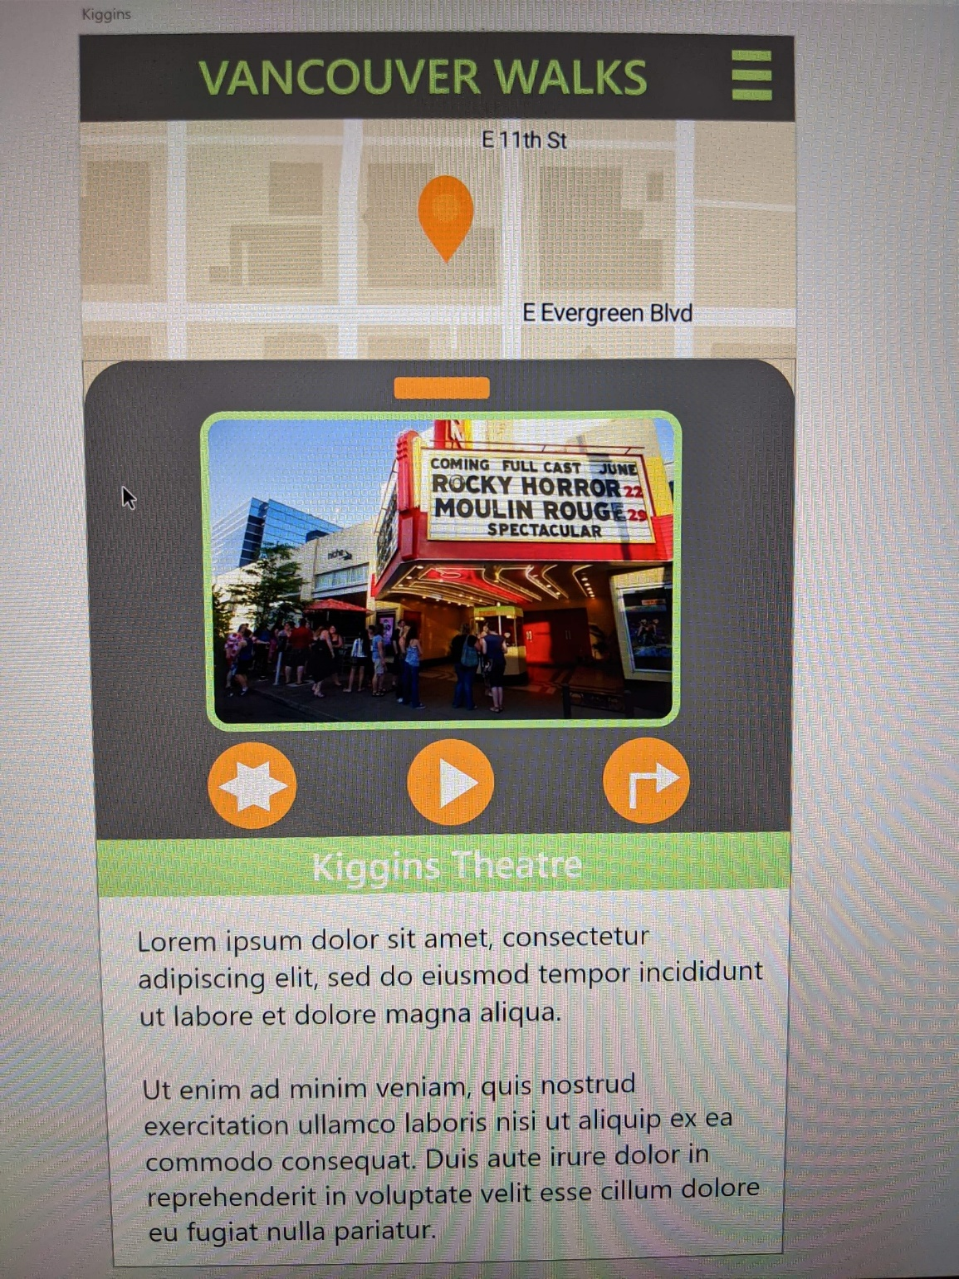
(Image courtesy of Grace Rouleau and created in Adobe XD)
Rather than focusing on the visual design aspect, this application focuses on human design and the overall functionality of the application. As Norman Don notes “Moreover, [Human-Centered Design] has demonstrated clear benefits: improved usability, less errors during usage, and faster learning times. What, then, are the concerns?” (Norman, Don) A major concern is that if the designer creates a product in a way that is comfortable to them, they risk alienating their audience in a case of clear only if known (COIK). However, if designed for the users there is a risk of which users to focus on, hence the Trifecta system which seeks to cater to multiple audiences while adding to the functionality of the application.

Works Cited
Adiseshiah, Emily Grace. “Best Practices for Prototyping Mobile User Experience.” UX and Prototyping Mobile Prototyping, JustInMind, 8 Mar. 2018, www.justinmind.com/blog/best-practices-for-prototyping-mobile-user-experience/.
Norman, Don. Human-Centered Design Considered Harmful. Jnd.org, 5 Jan. 2019, jnd.org/human-centered_design_considered_harmful/.
Rudenko, Anton. 10 Best Practices for Mobile UX Design. MLSDev, 30 Mar. 2016, mlsdev.com/blog/10-best-practices-for-mobile-ux-design.

